Samsung Galaxy S3 Gear
Name
Institution of Affiliation

SAMSUNG GALAXY S3 GEAR
TECHNICAL DESCRIPTION
INTRODUCTION
The Samsung Galaxy S3 gear is a smartwatch that enables the user to integrate the mobile handset with the wristwatch to allow remote access to the phone. It displays time and date and has applications that allow the user to access SMS, calls, and emails.

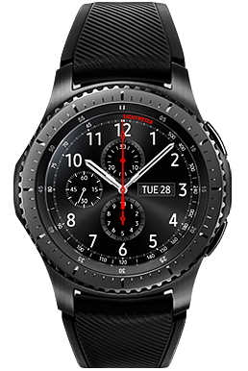

Samsung Galaxy S3 gear connects to Samsung phones and displays the data on the phone. This description is intended to describe to the end user the structure and the operation of the Samsung Galaxy S3 gear.
GENERAL DESCRIPTION
The S3gear is premium watch with advanced features made in a sleek design specially cut for the modern day man. It sets you free from your phone for days and enables easy

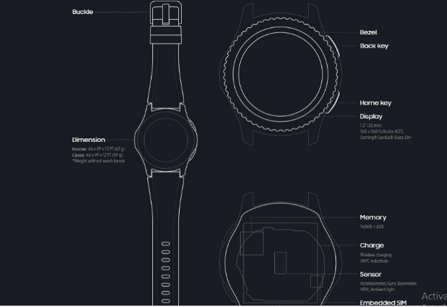
Operations at the tap of a finger. The main body is made of aluminium with curved edges. There is a two piece leather strap connected to the main body at the top and bottom. The body also has the home and back button for navigation.
Its main features include;
Handle band and Body
Card Slot
GPS tracker
Bluetooth
Messaging and Calling

DESCRIPTION OF PARTS
Strap and Body
The strap holds the user's wrist. The upper strap is 37mm wide and 126mm long at the end which connects to the main body. There are also a series of holes for the fastening stud to allow for adjusting to different arm widths.
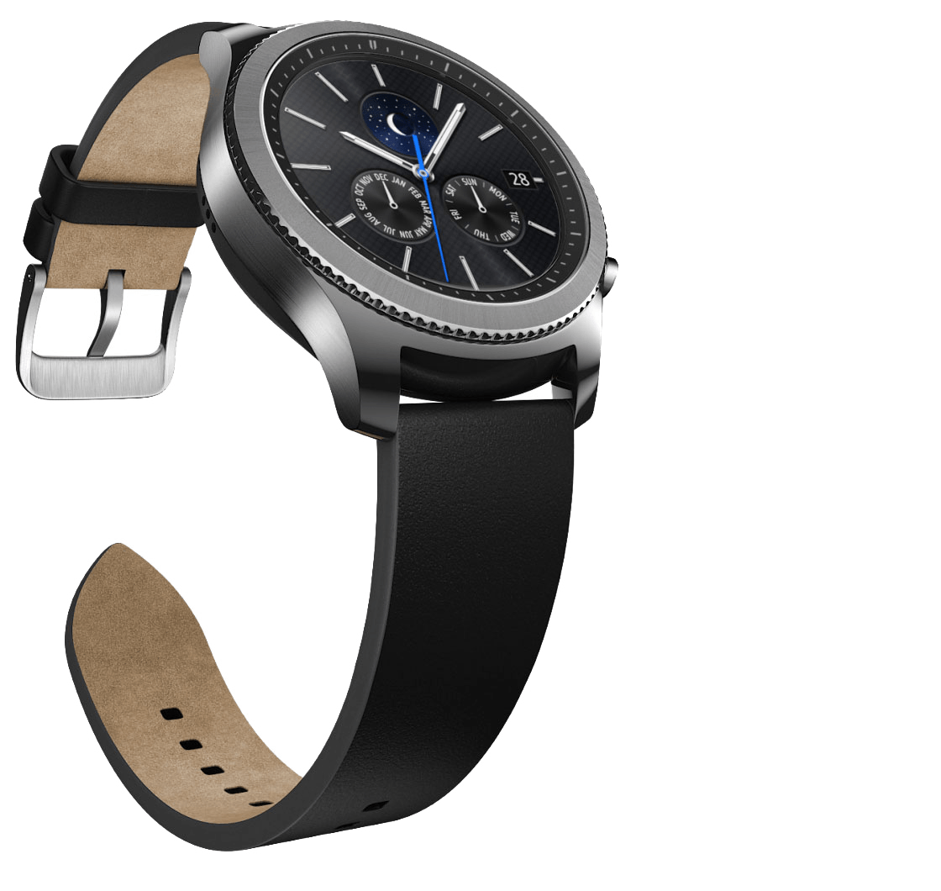
The straps are made smooth to ensure the user is comfortable. They also range
In different colors according to the user preference.
Card Slots
The Samsung s3 gear has a 768mb plus 4 GB storage for data, media, messaging and for supporting the OS of the smartwatch. One could also store personal files and documents that are linked to the mobile handset and access them remotely through the smartwatch.
GPS tracker
Without your phone, when out on excursions, you can check the distance you've covered, the route you need to take. You're able to track your progress from your daily runs to your golf score on the green. The GPS on the Gear S3 takes care of it all. This feature protects the mobile phone from damages that may come when out in the
field for sporting activities.


Bluetooth
The samsungs3 gear is equipped with Bluetooth BT4.2, Wi-Fi b/g/n NFC, MST, and GPS/GLONASS that allows connectivity between the mobile phone and the smartwatch. The smartwatch can also be connected to external Bluetooth headset for making and receiving calls.
Messaging and calling
The Samsung s3 gear has preinstalled applications that enable calling messaging and emailing without necessarily having your phone. You can reply to texts emails and receive calls with the smartwatch. The Samsung s3 gear also has built speakers to do so.

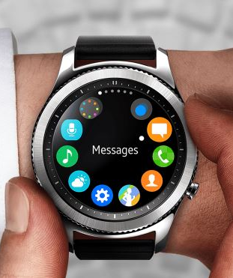
Setting up and compatibility
Setting up is as easy as using it. Open the Samsung Gear app on your smartphone to pair your Gear S3 and you're ready to go.

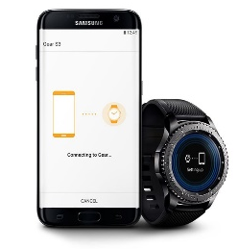
The Gear S3 also works with a wide range of smartphones. Compatible with Android 4.4 and higher with over 1.5GB RAM, iOS 9.0 and later, and smartphones iPhone 5 and newer.
However, Samsung's proprietary features may not be available for non-Samsung smartphones
Conclusion
The above features combined with style and elegance makes the Samsung s3 gear has a nice device to have. From emailing, instant messaging from the phone to maps and work out tracking. The display enables one to also scroll through the phone and adjust information to make it clear. The Samsung s3 gear is available at Samsung dealers worldwide and online stores at $400.

